2. 8-PUZZLE PROBLEM
Aim
To write a Python program to solve the 8-Puzzle problem.
Objective
To arrange the tiles in the correct order by moving the blank space.
Algorithm
- Define the initial state and goal state.
- Find the blank space.
- Move the blank tile to a valid position.
- Repeat until the goal state is reached.
- Display the solution.
Python code:
from collections import deque

start = tuple(map(int, input("Enter start state (9 numbers separated by space): ").split()))
goal = tuple(map(int, input("Enter goal state (9 numbers separated by space): ").split()))

moves = {
0:[1,3], 1:[0,2,4], 2:[1,5],
3:[0,4,6], 4:[1,3,5,7], 5:[2,4,8],
6:[3,7], 7:[4,6,8], 8:[5,7]
}

queue = deque([(start, [])])
visited = set()

while queue:
state, path = queue.popleft()

if state == goal:
print("Solved!")
print("Moves:", len(path))
print("Final State:", state)
break

if state in visited:
continue

visited.add(state)
blank = state.index(0)

for move in moves[blank]:
new = list(state)
new[blank], new[move] = new[move], new[blank]
queue.append((tuple(new), path + [tuple(new)]))
else:
print("No solution found.")
Flowchart: 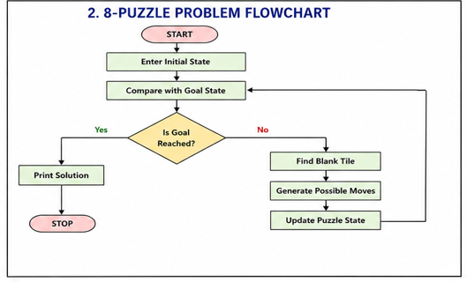

Output: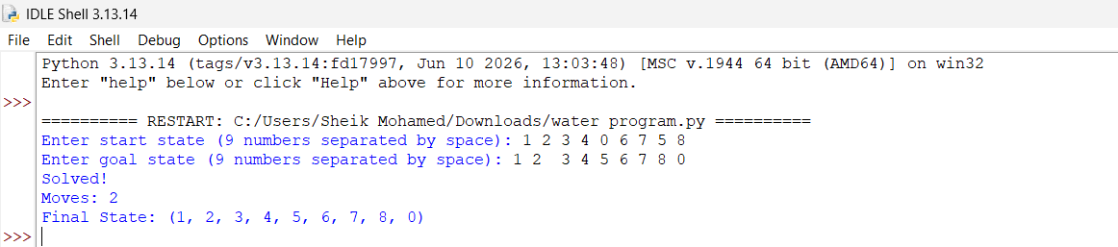
Result:
Thus, the Python program to solve the 8-Puzzle problem was executed successfully.

